Name: John Snawerdt

Course: CST-105

Date: 01/09/2018

Instructor: Mohamed Mneimneh

**CST-105: Programming Exercise 1**

**My Name is John Snawerdt and this work is my own.**

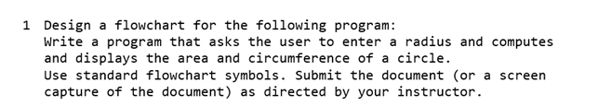

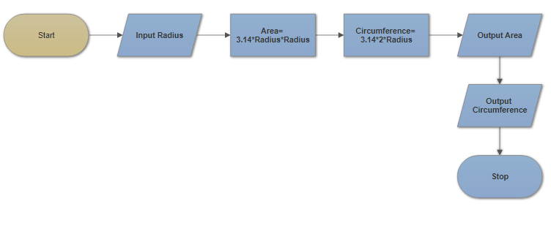

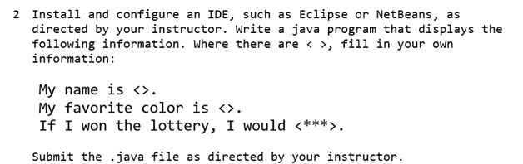

**Attached as Introduction.java**

